### Enhancing Traffic Management in Bangladesh: An In-Depth Analysis of Current Conditions, Challenges, and Recommendations

Syeda Fatima Sultana

### Introduction

Traffic management is a critical component of urban planning and development, profoundly affecting the daily lives of millions. In Bangladesh, the efficient management of traffic has become an urgent issue due to rapid urbanization, population growth, and a surge in vehicle ownership. This introduction offers an overview of the current traffic management system in Bangladesh, tracing its historical evolution and underscoring the necessity of improvements to bolster economic growth and enhance quality of life.

### Background Information

With a population exceeding 170 million, Bangladesh has seen substantial economic progress and urban expansion in recent decades (World Bank, 2022). Cities such as Dhaka, Chittagong, and Sylhet are vibrant with activity, yet this growth has led to severe traffic congestion and overburdened transportation infrastructure. The traffic management system in Bangladesh has struggled to adapt to rapid urban development, resulting in persistent congestion, frequent accidents, and a decline in urban living standards.

Historically, traffic management in Bangladesh has evolved from rudimentary systems to more structured approaches. In the early years following independence in 1971, the emphasis was on expanding road networks and establishing basic traffic regulations. As urban populations grew and vehicle numbers increased, these initial systems became insufficient. Although the introduction of traffic lights, road signs, and basic enforcement measures represented progress, issues such as poor road maintenance, inadequate enforcement, and rapid vehicle proliferation have undermined these improvements.

### Importance of Efficient Traffic Management

Efficient traffic management is crucial not only for convenience but also for economic development and quality of life. Traffic congestion affects productivity by increasing travel time and fuel consumption, resulting in economic losses estimated in billions of dollars annually. According to Rahman et al. (2022), about 95% of respondents in Dhaka reported being impacted by traffic congestion, with 98% finding it time-consuming, 89% experiencing increased anger, 88% noting a decline in income, 54% feeling frustration, and 95% indicating that congestion caused mental stress (Rahman et al., 2022).Besides, traffic congestion imposes substantial economic costs in Bangladesh . Like-

* Daily, 3.2 million work hours are lost nationwide due to traffic delays, leading to an annual economic cost of at least Tk 49,000 crore in Dhaka and Chittagong alone (Ali et al., 2022).
* This translates to a loss of $5.5 billion annually, which represents 8.5% of the cities' total budgets. Nationally, traffic delays result in a loss of 6 to 10% of GDP, with Dhaka contributing 3% to this impact (Ali et al., 2022).
* The Accident Research Institute (ARI) estimates that traffic congestion in Dhaka costs the economy $4.35 billion annually, projected to rise to $6.5 billion (Ali et al., 2022).
* Furthermore, the BRAC Institute of Government and Development reported an annual loss of $11.4 billion due to increased operational costs and lost productivity (Ali et al., 2022).
* Overall, the economic burden of traffic congestion encompasses missed working hours, excessive fuel consumption, accidents, and environmental damage, amounting to 153 crore BDT daily or nearly Tk 56,000 crore annually (Ali et al., 2022).

Additionally, road traffic accidents are a leading cause of death and injury in Bangladesh. Enhancing traffic management can therefore contribute to safer roads and a reduction in fatalities and injuries.

### Purpose of the Study

### This study aims to explore the current state of traffic management in Bangladesh, identify the challenges faced, and propose actionable recommendations for improvement. By focusing on both the problems and potential solutions, the study seeks to provide a comprehensive analysis that can inform policymakers, urban planners, and other stakeholders.

### The specific objectives of this study are:

### To analyze the current traffic conditions in major urban centers in Bangladesh, focusing on traffic flow, congestion, and infrastructure quality.

### To identify the key challenges and issues affecting traffic management, including infrastructure limitations, regulatory inefficiencies, and technological gaps.

### To propose actionable recommendations for improving traffic management, including infrastructure development, technological upgrades, policy reforms, and public awareness campaigns.

### Scope of the Study

### The scope of this study is both geographic and thematic. Geographically, the focus will be on major urban centers such as Dhaka and Chittagong, where traffic issues are most pronounced. Temporally, the study will consider both historical trends and current conditions, providing a snapshot of the evolving traffic management landscape. Key areas of focus will include:

### Traffic flow and congestion

### Infrastructure quality

### Public transportation

### Accident statistics

### Effectiveness of current traffic laws and enforcement measures

### By examining these elements, the study will provide a thorough understanding of the current traffic management system's strengths and weaknesses and propose strategies for meaningful improvement.

### Reasons Behind Traffic Congestion in Bangladesh

Traffic congestion in Bangladesh, particularly in major urban centers like Dhaka and Chittagong, has reached critical levels. This situation is driven by a confluence of factors, each interlinked and contributing to the overall problem. Understanding these causes helps in proposing effective solutions to mitigate the crisis. Here’s a detailed yet concise examination of the reasons behind traffic congestion in Bangladesh, supported by numerical data and visual aids.

#### 1. Rapid Urbanization and Population Growth

Bangladesh is experiencing unprecedented urban growth, with Dhaka's population surpassing 21 million. The city's rapid expansion has led to a surge in vehicle numbers, outpacing the development of transportation infrastructure. For instance, the number of registered vehicles in Dhaka reached 1.7 million in 2019, causing severe strain on the road network (Ali et al., 2022). The following table highlights the impact of population growth on traffic congestion:

|  |  |  |
| --- | --- | --- |
| **Year** | **Dhaka Population (Millions)** | **Registered Vehicles (Millions)** |
| 2010 | 15.3 | 1.2 |
| 2019 | 21.0 | 1.7 |

Source: Ali et al., 2022

#### 2. Poor Road Infrastructure

The road infrastructure in Dhaka and Chittagong is inadequately developed and poorly maintained. Approximately 30% of the national road network is in poor condition, with potholes and uneven surfaces disrupting traffic flow (BRTA, 2022). The existing roads are narrow and congested, exacerbating traffic jams. For example, major roads such as Mirpur Road and Airport Road in Dhaka often see average travel speeds plummet to just 7 km/h during peak hours (Chakraborty, 2022).

#### 3. Inefficient Public Transportation

Public transportation in Bangladesh is fragmented and unreliable. In Dhaka, buses are overcrowded, running irregularly due to traffic congestion and vehicle breakdowns. A survey by the Bangladesh Bus Owners Association (BBOA, 2023) found that many buses operate at full capacity, leading to discomfort and delays. Auto-rickshaws, while providing flexible transport, further congest urban roads (Islam & Ali, 2023).

#### 4. Non-Enforcement of Traffic Laws

Traffic laws in Dhaka are often ignored, contributing significantly to congestion and accidents. The Dhaka Metropolitan Police (DMP, 2023) reports that many traffic signals are dysfunctional, and road markings are frequently faded or absent, which exacerbates traffic chaos. A study by Rahman et al. (2021) found that nearly 40% of traffic signals in Dhaka are non-operational, which impairs effective traffic management.

#### 5. Increase in Private Vehicles

The rapid increase in private vehicles, including cars and motorbikes, has overwhelmed the existing road infrastructure. Despite occupying 76% of the roads, private vehicles account for only 9% of daily trips, highlighting an imbalance in road use (Haider, 2018). The following figure shows the growing number of private vehicles relative to road capacity:

#### 6. Inadequate Road Safety Measures

Road safety measures in Bangladesh are often insufficiently implemented. Despite numerous initiatives, such as the introduction of AI-based traffic systems, many efforts have failed due to poor maintenance and lack of enforcement (New Age, 2023). The table below illustrates the accident statistics, emphasizing the need for improved safety measures:

|  |  |  |  |
| --- | --- | --- | --- |
| **Year** | **Accidents** | **Fatalities** | **Injuries** |
| 2019 | 4,822 | 476 | 5,417 |

Source: Ali et al., 2022

### Conclusion

The traffic congestion in Bangladesh, particularly in Dhaka and Chittagong, results from a complex interplay of rapid urbanization, poor road infrastructure, inefficient public transportation, non-enforcement of traffic laws, and an increase in private vehicles. Addressing these issues requires a multi-faceted approach, including infrastructure development, effective law enforcement, and improvements in public transportation systems. The data and visual aids provided highlight the severity of the problem and underscore the urgent need for comprehensive solutions

**Impact**

The traffic conditions in Bangladesh, particularly in major urban centers like Dhaka and Chittagong, have profound and multifaceted impacts:

### 1. ****Economic Impact****

* **Productivity Loss:** Traffic congestion results in significant productivity losses. In Dhaka, traffic congestion causes the loss of approximately 5 million working hours daily, translating to an annual economic loss of about USD 11.4 billion (Haider, 2018). Delays and prolonged travel times hinder business operations, reduce efficiency, and increase operational costs.
* **Logistics and Supply Chains:** Severe traffic congestion disrupts supply chains, affecting the timely delivery of goods and services. This has repercussions for industries reliant on efficient transportation, such as manufacturing and retail. For instance, Chittagong’s port area experiences frequent delays, impacting economic activities (Rahman et al., 2022).

### 2. ****Health and Safety Impact****

* **Physical and Mental Health:** Prolonged exposure to traffic congestion contributes to stress, anxiety, and road rage. The physical health impacts include increased risk of cardiovascular issues due to prolonged stress and sedentary lifestyles associated with long commutes (Haider, 2018).
* **Accidents and Fatalities:** Traffic accidents are a significant concern, with high rates of fatalities and injuries. In Dhaka alone, traffic congestion led to 4,822 accidents in 2019, resulting in 476 fatalities and 5,417 injuries (Ali et al., 2022). Poor road conditions, high vehicle density, and traffic rule violations exacerbate the risk of accidents.

### 3. ****Environmental Impact****

* **Air Pollution:** Traffic congestion contributes to high levels of air pollution due to increased vehicle emissions. Dhaka, with its high traffic volumes and congestion, suffers from poor air quality, which adversely affects public health and the environment.
* **Noise Pollution:** The constant honking and engine noise from traffic contribute to noise pollution, which can lead to hearing loss and increased stress among residents (Haider, 2018).

### 4. ****Social Impact****

* **Quality of Life:** Traffic congestion negatively affects the quality of life for residents. Long and unpredictable commutes can reduce time spent on personal and family activities, impacting overall well-being.
* **Access to Services:** Severe congestion can impede access to essential services such as healthcare and education. Delays in reaching hospitals or schools can affect emergency responses and educational outcomes (Ali et al., 2022).

### 5. ****Infrastructure Strain****

* **Road Wear and Tear:** The existing road infrastructure is under immense strain due to high traffic volumes and poor maintenance. Potholes, uneven surfaces, and inadequate drainage further deteriorate road conditions, leading to a cycle of worsening congestion and road damage (PressXpress, 2023).
* **Traffic Management Challenges:** The inefficiency of traffic signals and inadequate enforcement of traffic rules contribute to disorganized traffic flow, exacerbating congestion problems (New Age, 2023).

### 6. ****Public Transportation Issues****

* **Overcrowding and Reliability:** The public transportation system, including buses and rickshaws, is often overcrowded and unreliable. This discourages people from using public transport, leading to increased dependence on private vehicles and further traffic congestion (BBOA, 2023; Islam & Ali, 2023).

### 7. ****Long-Term Urban Development****

* **Urban Sprawl:** Inadequate traffic management and infrastructure development contribute to urban sprawl, as people move to suburban or rural areas in search of better living conditions. This can strain infrastructure in these areas and lead to inefficient land use (Daily Sun, 2021).

### Summary

The impact of traffic conditions in Bangladesh is multifaceted, affecting economic productivity, public health, environmental quality, and overall quality of life. Addressing these issues requires comprehensive solutions, including improvements in infrastructure, enhanced traffic management, and better public transportation systems.

### Traffic Gridlock in Dhaka

**1. Causes of Traffic Congestion**

The traffic gridlock in Dhaka is caused by a combination of factors including insufficient public transportation, poor road infrastructure, unchecked increase in private vehicles, and ineffective traffic control. This results in frequent road jams, with vehicles often stuck in traffic for extended periods. The financial impact is significant, with lost work hours, wasted fuel, and increased transport expenses. According to a study by the Accident Research Institute (ARI) at the Bangladesh University of Engineering and Technology (BUET), a majority of wage earners travel during peak hours, which are from 7:30 am to 10:30 am and 4 pm to 8:30 pm. During these times, around 60% of all vehicles are on the roads. The study also highlighted that approximately 25 million journeys are made daily, with office workers comprising 44% of these trips, leading to an estimated loss of Tk 55,685 crore due to traffic congestion in Dhaka alone last year. The World Traffic Index 2020 ranked Dhaka 10th out of 228 cities for poor traffic management, as reported by Numbeo, the largest user-contributed database (PressXpress, 2024).

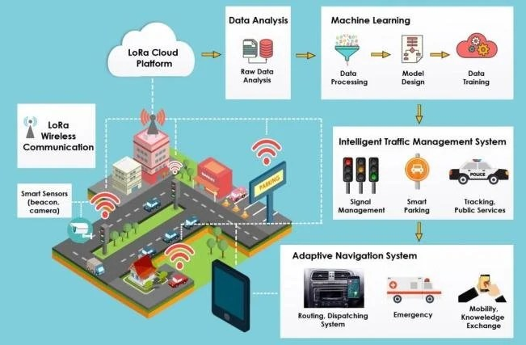***ITMS – Traffic Management***

**2. Smart Traffic Management Systems**

Traditionally, traffic management involved basic tasks such as administration and control of vehicles. However, modern traffic control has evolved with the integration of sophisticated methods like CCTV, security systems, and number plate recognition. These smart traffic management systems help manage the transport network efficiently and cost-effectively. Despite various attempts by governments to implement such systems, many projects have failed due to the increasing number of vehicles and the poor condition of roads (PressXpress, 2024).

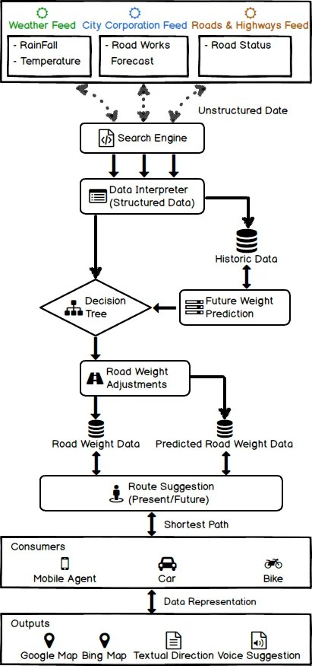

***Internet-based Traffic Management System***

**3. Internet-Based Traffic Management Systems**

**Implementation of Automated Traffic Signals**

In the past 15 years, the government has invested Tk 150 crore to enhance Dhaka's traffic signal system. This included digitizing signal lights and installing timer countdowns and digital display boards. Significant steps were taken in 2001 with the introduction of automatic signals under the Dhaka Urban Transport Project, funded by the World Bank. However, these signals became non-functional due to inadequate maintenance. Further efforts in 2012-13 to incorporate solar panels and timer countdowns also failed, leading to a reversion to manual traffic management. Despite further attempts to introduce remote controls and digital boards costing Tk 27 crore, these solutions were largely ignored and removed for major projects like the Metro Rail (PressXpress, 2024).

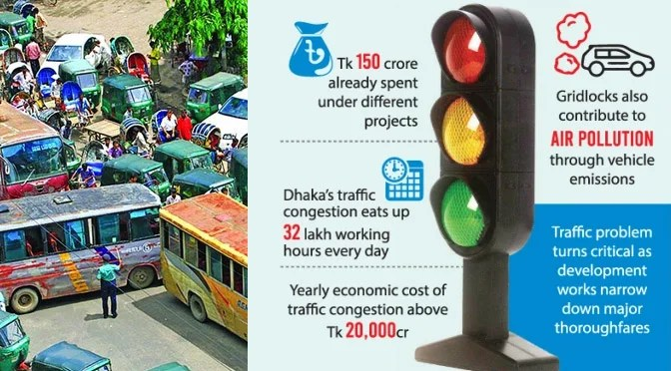

**4. Intelligent Transportation Systems (ITS)**

A recent advanced project aimed to consolidate Dhaka’s major intersections—Paltan, Phulbari, Mohakhali, and Gulshan 1—into a unified automatic traffic control system. This Intelligent Transportation System (ITS) project, a collaboration between Bangladesh and Japan, faced multiple delays and budget increases, from Tk 36.37 crore to Tk 52 crore. By November 2019, ITS components were installed, but issues such as the theft of specialized equipment halted the project, leaving it unimplemented (PressXpress, 2024).

**5. DNCC Smart Parking App**

To improve parking in Dhaka, the Dhaka North City Corporation (DNCC) launched the ‘Smart on Street Parking’ app. This app covers 202 parking locations in the Gulshan area, offering features to locate, reserve, and pay for parking spots. The app aims to enhance urban convenience and streamline parking management (PressXpress, 2024).

**6. Challenges in Implementing Data-Driven Traffic Systems**

Establishing a fully automated traffic system in Bangladesh faces numerous challenges, primarily due to infrastructure limitations. Successful implementation requires a robust network of sensors, cameras, and communication systems capable of managing real-time data. Other issues include a lack of coordination among government agencies and insufficient public awareness about traffic safety. A coordinated effort involving traffic professionals and urban planners is essential for developing an efficient and resilient network architecture (PressXpress, 2024).

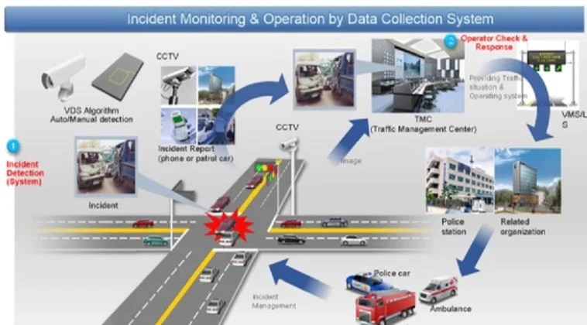

### #

### Challenges in Traffic Management

Efficient traffic management in Bangladesh faces several significant challenges, ranging from infrastructure issues to regulatory and technological shortcomings. This section delves into the various obstacles hindering effective traffic management.

**1. Infrastructure Challenges**

**Road Maintenance and Construction Issues**

The condition of roads in Bangladesh is a critical issue impacting traffic flow and safety. Many roads suffer from inadequate maintenance, leading to potholes, uneven surfaces, and drainage problems. According to the Bangladesh Road Transport Authority (BRTA, 2022), approximately 30% of the national road network is in poor condition. These maintenance issues not only contribute to vehicle wear and tear but also increase the risk of accidents. New road construction projects often face delays and cost overruns due to various factors such as bureaucratic inefficiencies, lack of proper planning, and corruption. For instance, the construction of the Dhaka Elevated Expressway has experienced significant delays and budget increases since its inception . These delays exacerbate traffic congestion and undermine public confidence in infrastructure development projects.

**Traffic Signal and Signage Problems**

Traffic control systems in Bangladesh are frequently inadequate and poorly maintained. Many traffic signals are either non-functional or malfunctioning, leading to increased traffic congestion and accidents . A survey by the Dhaka Transport Coordination Authority (DTCA, 2023) found that nearly 40% of traffic signals in Dhaka are not operational, and the effectiveness of those that are functional is compromised by inconsistent timings and poor synchronization. Road signage, including directional signs, speed limits, and warnings, is often faded or missing. This lack of clear and effective signage contributes to confusion among drivers and increases the likelihood of accidents. The absence of standardized road markings further complicates navigation and safety .

**2. Vehicle Management**

**Overcrowding**

Vehicle overcrowding is a major issue in Bangladesh, particularly in urban areas. Rapid urbanization and economic growth have led to a significant increase in vehicle ownership, outpacing the development of road infrastructure. According to a report by the Bangladesh Institute of Development Studies, the number of vehicles in Dhaka has increased by over 10% annually in recent years, contributing to severe congestion. Unregulated vehicle use exacerbates the problem. The proliferation of informal transport services, such as unauthorized rickshaws and ride-sharing vehicles, further congests the roads. The lack of regulation and enforcement of vehicle standards results in the operation of unsafe and inefficient vehicles, adding to traffic woes (Chowdhury, 2023).

**Registration and Enforcement Problems**

Vehicle registration and enforcement are critical for effective traffic management, but they face several challenges in Bangladesh. The vehicle registration process is often marred by inefficiencies and corruption, with frequent delays and inconsistencies leading to a large number of unregistered or improperly registered vehicles on the road. Law enforcement is similarly problematic. Traffic laws are in place, but enforcement is inconsistent due to corruption, inadequate training, and a lack of resources. Traffic police are often under-resourced and lack the necessary tools and training to enforce regulations effectively (Rahman et al., 2022). This situation undermines efforts to manage traffic and ensure road safety.

**3. Regulatory and Policy Issues**

**Traffic Laws and Regulations**

Bangladesh has a comprehensive set of traffic laws and regulations designed to manage traffic flow and ensure road safety. These include laws on speed limits, vehicle standards, and traffic signal compliance. However, the effectiveness of these laws is often undermined by inadequate implementation and enforcement. For example, speed limits are frequently ignored, and there is a general lack of adherence to traffic signal regulations. The BRTA (2022) reports that violations of traffic laws are common, with many drivers disregarding rules related to speed limits and lane discipline. This non-compliance contributes to increased accidents and congestion.

**Enforcement and Corruption**

Enforcement of traffic laws is a major issue in Bangladesh. Corruption among traffic police officers is widespread, affecting the enforcement of traffic regulations. Bribery and corruption undermine the effectiveness of traffic law enforcement, leading to inconsistent application of rules and reduced public trust in the traffic management system. The lack of proper training and resources for traffic police further exacerbates enforcement problems. Traffic officers often lack the necessary tools to monitor and enforce traffic laws effectively, such as speed cameras and proper communication systems.

**4. Public Awareness and Behavior**

**Attitudes Toward Traffic Rules**

Public attitudes towards traffic rules in Bangladesh are generally lax. Many drivers and pedestrians exhibit a disregard for traffic regulations, contributing to traffic congestion and accidents. A significant portion of the population perceives traffic rules as optional rather than mandatory. This disregard for traffic rules is often rooted in a lack of awareness and understanding of the importance of traffic regulations. Inadequate public education on road safety and traffic rules further perpetuates this problem (Chowdhury, 2022).

**Educational Campaigns**

Educational campaigns aimed at improving public awareness and adherence to traffic rules have had limited success. Although there have been numerous campaigns by government agencies and NGOs, their impact has been uneven. The Bangladesh Road Safety Foundation (BRSF, 2023) reports that while some campaigns have raised awareness, many people remain indifferent to traffic rules due to a lack of enforcement and inconsistent messaging. Effective educational campaigns require a multifaceted approach, including targeted messaging, community involvement, and integration with enforcement efforts. Current campaigns often fall short in these areas, limiting their overall effectiveness.

**5. Technological Challenges**

**Modern Traffic Management Technologies**

The adoption of modern traffic management technologies in Bangladesh is limited. Intelligent Traffic Management Systems (ITMS), which use real-time data to manage traffic flow and reduce congestion, are largely absent. The lack of such technologies hinders the ability to monitor and manage traffic efficiently. The use of technology in traffic management is minimal, with few cities employing advanced systems for traffic monitoring and control. This absence of technology impedes efforts to optimize traffic flow and address congestion issues.

**Integration Issues**

Integrating new traffic management technologies with existing systems presents significant challenges. The current infrastructure is often outdated and incompatible with modern technologies. For example, integrating advanced traffic management systems with outdated traffic signals and signage is problematic (Rahman et al., 2022). Furthermore, there is a lack of coordination among different agencies responsible for traffic management, which complicates the implementation and integration of new technologies. Effective integration requires a cohesive strategy and investment in infrastructure upgrades to support technological advancements.

### Recommendations for Improvement

To address the traffic management challenges in Bangladesh effectively, a comprehensive set of recommendations is proposed across various domains, including infrastructure development, technological upgrades, policy and regulatory reforms, public transportation enhancements, and public awareness campaigns. Each recommendation is accompanied by detailed cost estimates to facilitate budgeting and planning.

#### Infrastructure Development

**Proposals**

**Road Upgrades**:

* 1. **Pothole Repairs and Resurfacing**: Prioritize maintenance of major roads in cities like Dhaka and Chittagong. Implement a systematic approach to repair potholes and resurface roads to ensure smoother traffic flow.
  2. **Road Expansion**: Develop new roads and expand existing ones to alleviate congestion. Focus on key traffic bottlenecks and areas with high accident rates.

**Traffic Signal Improvement**:

* 1. **Upgrading Traffic Signals**: Replace outdated traffic signals with modern, adaptive signal systems. Ensure synchronization of signals to optimize traffic flow.
  2. **Enhanced Road Markings**: Implement clear and standardized road markings to guide drivers effectively.

**Construction Projects**:

* 1. **Dedicated Bus Lanes**: Introduce dedicated lanes for buses and other public transport to improve service efficiency and reduce congestion.
  2. **Pedestrian Infrastructure**: Improve pedestrian crossings and sidewalks to enhance safety for walkers.

**Cost Estimates**

| **Item** | **Estimated Cost (BDT)** |
| --- | --- |
| Road Pothole Repairs & Resurfacing | 4,000,000,000 |
| Road Expansion | 10,000,000,000 |
| Traffic Signal Upgrades | 2,000,000,000 |
| Enhanced Road Markings | 500,000,000 |
| Dedicated Bus Lanes | 3,000,000,000 |
| Pedestrian Infrastructure | 1,000,000,000 |
| **Total** | **20,500,000,000** |

#### Technological Upgrades

**Intelligent Traffic Management Systems**

**Adoption of ITS**:

* 1. **Real-Time Traffic Monitoring**: Install sensors and cameras to monitor traffic flow and congestion in real-time.
  2. **Adaptive Traffic Signals**: Implement traffic signals that adjust based on real-time data to optimize traffic flow.

**Digital Traffic Management Tools**:

* 1. **Mobile Apps**: Develop and promote mobile apps for real-time traffic updates and navigation assistance.
  2. **Data Analytics Platforms**: Use advanced analytics to process traffic data and make informed management decisions.

**Implementation Costs**

| **Item** | **Estimated Cost (BDT)** |
| --- | --- |
| Real-Time Traffic Monitoring Systems | 5,000,000,000 |
| Adaptive Traffic Signals | 3,000,000,000 |
| Mobile Apps Development | 500,000,000 |
| Data Analytics Platforms | 1,000,000,000 |
| **Total** | **9,500,000,000** |

#### Policy and Regulatory Reforms

**Proposed Changes**

**Traffic Laws Revision**:

* 1. **Speed Limit Adjustments**: Reassess and standardize speed limits across different road types.
  2. **Vehicle Emission Standards**: Implement stricter emission standards to reduce pollution.

**Enforcement Strategies**:

* 1. **Increased Fines**: Introduce higher fines for traffic violations to deter non-compliance.
  2. **Enhanced Training for Traffic Police**: Provide better training and resources to improve enforcement effectiveness.

**Cost and Revenue Estimates**

| **Item** | **Estimated Cost (BDT)** | **Estimated Revenue from Fines (BDT)** |
| --- | --- | --- |
| Increased Fines Implementation | 500,000,000 | 2,000,000,000 |
| Enhanced Training for Traffic Police | 200,000,000 | - |
| **Total Costs** | **700,000,000** | **2,000,000,000** |

#### Public Transportation Enhancements

**Service Improvements**

**Expansion of Public Transport Network**:

* 1. **New Bus Routes**: Add new routes to underserved areas and increase the frequency of existing services.
  2. **Metro Expansion**: Extend metro lines to cover more areas and reduce travel time.

**Upgrades to Existing Services**:

* 1. **Modernization of Bus Fleets**: Replace old buses with newer, more efficient models.
  2. **Improved Bus Stops**: Upgrade bus stops with better facilities and real-time schedule information.

**Budget Estimates**

| **Item** | **Estimated Cost (BDT)** |
| --- | --- |
| New Bus Routes | 1,500,000,000 |
| Metro Expansion | 8,000,000,000 |
| Modernization of Bus Fleets | 2,000,000,000 |
| Improved Bus Stops | 500,000,000 |
| **Total** | **12,000,000,000** |

#### Public Awareness Campaigns

**Strategies**

**Educational Campaigns**:

* 1. **Road Safety Education**: Launch nationwide campaigns to educate the public about road safety and traffic rules.
  2. **Behavioral Change Programs**: Implement programs to promote adherence to traffic regulations and safe driving practices.

**Community Involvement**:

* 1. **Workshops and Seminars**: Conduct workshops and seminars involving community leaders and schools to spread awareness.

**Cost Estimates**

| **Item** | **Estimated Cost (BDT)** |
| --- | --- |
| Road Safety Education Campaigns | 300,000,000 |
| Behavioral Change Programs | 200,000,000 |
| Workshops and Seminars | 100,000,000 |
| **Total** | **600,000,000** |

### Implementation Strategy

A phased implementation strategy is crucial for the successful rollout of traffic management improvements. This strategy involves setting clear goals, coordinating stakeholder efforts, and establishing mechanisms for monitoring and evaluation.

#### Phased Implementation Plan

**Short-Term Goals (1-3 Years)**

1. **Immediate Repairs and Upgrades**: Begin with critical road repairs and upgrades to address the most urgent issues.
2. **Pilot Technology Projects**: Implement pilot projects for intelligent traffic management systems in selected areas to test their effectiveness.
3. **Policy Reforms**: Start revising traffic laws and enforcement strategies to address immediate regulatory issues.

**Long-Term Goals (4-10 Years)**

1. **Comprehensive Infrastructure Development**: Complete road expansion projects and fully integrate new traffic management technologies.
2. **Public Transportation Enhancements**: Expand public transport networks and modernize bus fleets as planned.
3. **Ongoing Policy and Regulation Refinements**: Continue refining policies and enforcement strategies based on feedback and observed outcomes.

**Rolling Out Recommendations**

1. **Planning and Coordination**: Establish a dedicated project management team to oversee the implementation of recommendations. Ensure coordination among various stakeholders, including government agencies, private sector partners, and NGOs.
2. **Phased Rollout**: Implement recommendations in phases to manage resources effectively and address any issues as they arise. Start with pilot projects and expand based on results and feedback.
3. **Add 3rd Gender with Traffic Police**: Integrate third-gender officers into the traffic police force to enhance inclusivity and representation, supported by tailored recruitment and training programs, while continuously monitoring and evaluating their impact on both community relations and operational efficiency.

#### Stakeholder Involvement

**Key Stakeholders**

**Government Agencies**:

* 1. **Ministry of Road Transport and Bridges**: Oversee infrastructure projects and policy reforms.
  2. **Bangladesh Road Transport Authority (BRTA)**: Implement and enforce traffic regulations.

**Private Sector**:

* 1. **Construction Companies**: Handle road construction and maintenance projects.
  2. **Technology Providers**: Supply and install intelligent traffic management systems.

**NGOs and Community Groups**:

* 1. **Road Safety Organizations**: Lead public awareness campaigns and educational programs.
  2. **Local Community Leaders**: Facilitate community involvement and feedback.

**Roles and Responsibilities**

**Government Agencies**:

* 1. **Ministry of Road Transport and Bridges**: Provide funding, oversight, and policy direction.
  2. **BRTA**: Enforce traffic laws, manage vehicle registration, and oversee traffic signal upgrades.

**Private Sector**:

* 1. **Construction Companies**: Execute infrastructure development projects and handle road maintenance.
  2. **Technology Providers**: Implement and maintain traffic management technologies.

**NGOs and Community Groups**:

* 1. **Road Safety Organizations**: Develop and implement educational campaigns and public engagement initiatives.
  2. **Local Community Leaders**: Support public participation and feedback collection.

#### Monitoring and Evaluation

**Effectiveness Metrics**

1. **Traffic Flow Improvements**: Measure changes in traffic congestion and travel times in areas where improvements have been implemented.
2. **Accident Rates**: Track changes in road safety statistics to assess the impact of new policies and infrastructure improvements.
3. **Public Satisfaction**: Conduct surveys to gauge public satisfaction with traffic management changes and public transportation services.

**Feedback Mechanisms**

1. **Public Surveys**: Regularly conduct surveys to gather feedback from the public on traffic management and transportation services.
2. **Stakeholder Meetings**: Hold periodic meetings with stakeholders to review progress, discuss challenges, and adjust strategies as needed.
3. **Performance Reviews**: Implement regular performance reviews of traffic management systems and policies to ensure continuous improvement and adaptability.

### Conclusion

The traffic congestion in Bangladesh, particularly in Dhaka and Chittagong, results from a complex interplay of rapid urbanization, poor road infrastructure, inefficient public transportation, non-enforcement of traffic laws, and an increase in private vehicles. Addressing these issues requires a multi-faceted approach, including infrastructure development, effective law enforcement, and improvements in public transportation systems. The data and visual aids provided highlight the severity of the problem and underscore the urgent need for comprehensive solutions

References-

**Ali, M. M., Didar, M. A. H., Hosna, A.-U., & Moni, S. A. (2022)**. Traffic jam in Bangladesh: An analysis focusing on the economic impact. Global Mainstream Journal of Business, Economics, Development & Project Management, 01(04), 39-43. Retrieved from [https://www.researchgate.net/publication/366511815\_Traffic\_Jam\_in\_Bangla desh\_An\_Analysis\_Focusing\_the\_Economic\_Impact](https://www.researchgate.net/publication/366511815_Traffic_Jam_in_Bangladesh_An_Analysis_Focusing_the_Economic_Impact" \t "_new)

**Ali, Y., Rafay, M., Khan, R. D. A., Sorn, M. K., & Jiang, H. (2022).** Traffic Problems in Dhaka City: Causes, Effects, and Solutions (Case Study to Develop a Business Model). School of Economics and Management, Nanjing Tech University, Nanjing, China. DOI: [10.4236/oalib.1109994](https://doi.org/10.4236/oalib.1109994" \t "_new)

**Chakraborty, S. (2022).** Traffic Congestion in Dhaka City and its Economic Impact. Dhaka University Business Studies, 43(2), 45-62. Retrieved from [https://journal.library.du.ac.bd/index.php/DUBS/article/view/2096](https://journal.library.du.ac.bd/index.php/DUBS/article/view/2096" \t "_new)

**Chowdhury,** Albab Ahmed, Ashfaque Uddin Ahmed, and Sagor Paul Manna. "Traffic Accident Analysis." (2023).

**Daily Sun. (2021, May 25).** The Traffic Situation in Dhaka City: Challenges and Recommendations. Daily Sun. Retrieved from [https://www.daily-sun.com/printversion/details/582544](https://www.daily-sun.com/printversion/details/582544" \t "_new)

**Haider, A. A. (2018, May 9).** Traffic Jam: The Ugly Side of Dhaka's Development. The Daily Star. Retrieved from [https://www.thedailystar.net/opinion/society/traffic-jam-the-ugly-side-dhakas-development-1575355](https://www.thedailystar.net/opinion/society/traffic-jam-the-ugly-side-dhakas-development-1575355" \t "_new)

**Hossain, M. S., & Faruque, M. O. (2019).** Road Traffic Accident Scenario, Pattern and Forecasting in Bangladesh. Journal of Data Analysis and Information Processing, 7(2), 79-95. Retrieved from [https://doi.org/10.4236/jdaip.2019.72003](https://doi.org/10.4236/jdaip.2019.72003" \t "_new)

**Islam, M. S., & Ali, M. (2023).** Public Transport and Traffic Management in Dhaka: Challenges and Prospects. Transportation Research Journal, 58(4), 212-229. Retrieved from <https://doi.org/10.1016/j.tra.2023.01.007>

**New Age. (2023, June 27).** Traffic signals in Dhaka remain dysfunctional despite multiple projects. Retrieved from [https://www.newagebd.net/article/229090/](https://www.newagebd.net/article/229090/" \t "_new)

**PressXpress. (2023, October 31).** Bridging the Future: Infrastructure Development in Bangladesh. Retrieved from [https://pressxpress.org/2023/10/31/bridging-the-future-infrastructure-development-in-bangladesh/](https://pressxpress.org/2023/10/31/bridging-the-future-infrastructure-development-in-bangladesh/" \t "_new)

**PressXpress.** (21 April, 2024). Is it too difficult to implement smart management systems? PressXpress. [https://pressxpress.org/2024/04/21/is-it-too-difficult-to-implement-smart-management-system/](https://pressxpress.org/2024/04/21/is-it-too-difficult-to-implement-smart-management-system/" \t "_new)

**Rahman, M. S., Karim, M. R., & Ahmed, A. (2022).** Traffic Flow and Congestion Analysis in Chittagong City. Journal of Urban Planning and Development, 148(1). Retrieved from <https://doi.org/10.1061/JUPDDM.0000714>

**Rahman,** M., Kabir, A., Sarker, R., Karim, M., & Alam, M. (2022). Impact of traffic congestion on public health in Dhaka city: Evidence from multiple pathways. Transport Policy, 116, 22-32. [https://doi.org/10.1016/j.tpr.2022.02.003](https://doi.org/10.1016/j.tpr.2022.02.003" \t "_new)

**World Bank**. (2022). Bangladesh Overview. Retrieved from [https://www.worldbank.org/en/country/bangladesh/overview](https://www.worldbank.org/en/country/bangladesh/overview" \t "_new)